**Using light stable isotopes to assess stream food web ecology in a general ecology laboratory course**

Hannah M. Carrolla, Derek D. Houstonb, Suzanne Ankerstjernec, and Alan D. Wanamaker, Jr.c

a Department of Ecology Evolution and Organismal Biology, Iowa State University, Ames, IA, USA; b Department of Natural and Environmental Sciences, Western Colorado University, Gunnison, CO, USA; c Department of Geological and Atmospheric Sciences, Iowa State University, Ames, IA, USA

**Abstract**

Stable isotopes in natural materials provide a powerful way to study energy flow in many systems and are widely used in fields such as archaeology, ecology, forensics, geochemistry, geology, oceanography, paleoecology and paleoclimatology. Based on the manner in which stable isotopes fractionate in natural systems, they allow scientists to address a wide-array of research topics ranging from tracking climatic shifts, ascertaining organisms’ migratory patterns, matching organisms to their diets and/or environments, assessing food web bioenergetics, documenting ecosystem changes through time, measuring soil carbon budgets and soil microbial activity, etc. Students with no prior experience working with stable isotopes successfully met learning objectives by completing the requisite field and laboratory protocols, analyzing data, interpreting results, and communicating their findings in a report modeled after a peer-reviewed scientific journal article. While this activity focused on food web ecology in a stream ecosystem, the method is repeatable, cost-effective, and can be modified relatively easily to evaluate food webs in virtually any other ecosystem.

**Keywords**

Active Learning; Biological Education; Community Ecology; Experiential Learning; δ13C; δ15N; Light Stable Isotopes

**Introduction**

Stable isotopes are alternate forms of atoms that differ in the number of neutrons contained within their nuclei. Stable isotopes maintain the same chemical properties of their elements, but differ in their atomic mass (Fry 2006). They are non-radioactive atoms that do not experience radioactive decay (as opposed to radioactive isotopes such as carbon-14/carbon-12 that are commonly used in radiometric dating). Stable isotopes are powerful tools used in many scientific disciplines including community ecology, climate science, fisheries biology, paleoecology, geology, forensic science, archaeology, soil science, and many others. Due to fractionation processes, the partitioning of heavy and light isotopes in natural materials, largely due to mass effects (Sharp 2007), the stable isotope signature in such materials provides clues about energy flow and/or environmental conditions. Thus, stable isotopes are commonly used to track changes in climate (Cerling 1984, Lipp et al. 1991, McDermott 2004, West et al. 2006, Baker et al. 2017), ascertain migratory patterns (Rubenstein et al. 2002, Rubenstein and Hobson 2004, Hobson 2016), match organisms to their environments (Bearhop et al. 2004, Hogan et al. 2014) or diets (Hilderbrand et al. 1996, Richards et al. 2000, Bearhop et al. 2003, Divine et al. 2017, Patterson et al. 2019), assess food web bioenergetics (Hobson et al. 1994, Vander Zanden M. J. et al. 1999, Hershey et al. 2017), document ecosystem and environmental changes through time (O’Reilly et al. 2003, Reynolds et al. 2016, 2017, Whitney et al. 2019), measure soil carbon budgets (Hsieh and Yapp 1999, Bridgham et al. 2006), assess soil microbial activity (Boschker and Middelburg 2002, Steinbeiss et al. 2009), and other topics.

Commonly used light stable isotopes include hydrogen, carbon, oxygen, nitrogen, and sulfur. Stable isotopes are measured as a function of the ratio of the more common isotope to the less common isotope, relative to the same ratio measured in an international standard. This value is multiplied by 1,000, and the results are reported in parts per thousand (permil; ‰). Researchers can examine isotopic ratios, designated as delta values (δ) (see Equation 1),

 = ((Rx – Rstd)/Rstd) *1000 Eq. 1

where R is the ratio of the abundance of the heavy to light isotope (e.g., 2H/1H, 13C/12C, 18O/16O, 15N/14N, 34S/32S), x denotes sample, and std is the abbreviation for standard, to answer questions of interest (Peterson and Fry 1987, Fry 2006). For example, the δ18O value in mollusk shell material is commonly used to constrain seawater temperature conditions at the time of deposition when the isotopic composition of the water is known or can be reliably estimated (Epstein et al. 1953, Wanamaker et al. 2007). Another example is the use of δ13C and δ15N values to infer animal diets and evaluate ecosystem trophic structure (Hershey et al. 2017).

Using carbon from a plant as an example, researchers would place a sample in an elemental analyzer along with an international standard for carbon, on the Vienna Pee Dee Belemnite (VDPB) scale. The elemental analyzer combusts the sample producing CO2, and a mass spectrometer measures the intensities of the rare isotope (13C16O2; mass 45) and the common isotope (12C16O2; mass 44) via Faraday cups, and provides an isotopic ratio based on the relative intensities of mass 45 and mass 44 derived from the plant’s tissues. The instruments then repeat the measurements on a number of international isotopic standards with well-constrained δ13C values and are used to place the samples on the international isotope scale, VPDB. Organic carbon is almost always isotopically negative. For example, the tissues of plants range from a δ13C of -10‰ to -29‰ (O’Leary 1988), depending on the kind of plant (C3, C4, or CAM) and its environment. This is because plants preferentially incorporate the lighter isotope of carbon, which is the most common in nature (more than 98% of the global carbon pool). The negative value simply shows that there is less of the heavier (rare) isotope relative to the lighter (common) one in the plant’s tissues when compared to the standard. This property whereby one isotope of an element is incorporated relatively more than another is called fractionation, and can be utilized to understand the flow of energy through systems, including food web ecology. Generally speaking, lighter isotopes have weaker bonds than heavier isotopes (Sharp 2007), thus it is thermodynamically easier for 12C rather than 13C to be incorporated into the leaf of a plant during photosynthesis.

Organisms within an ecosystem are often grouped into trophic levels that are descriptive of how they attain their energy. Producers (autotrophs) comprise the lowest trophic level of a system and convert light (or chemical) energy into usable forms of chemical energy (e.g., sugars). Consumers (heterotrophs) are organisms that gain energy by consuming producers, and can be classified as primary consumers (herbivores, planktivores), secondary consumers (carnivores), tertiary consumers (sometimes carnivores, sometimes omnivores), and apex predators that feed on primary, secondary, and tertiary consumers if there is enough energy in the system to support that many trophic levels. In most cases, approximately 10% of the energy at one trophic level is incorporated into biomass at the next highest trophic level, although that varies from system to system (Molles and Sher 2019).

Freshwater ecosystems receive organic matter from terrestrial environments that is incorporated as allochthonous material (e.g., dead leaves, fallen branches), otherwise described as course particulate organic matter (CPOM), and impacts energy flow. Organisms called shredders (e.g., crane flies, some caddisflies, some stoneflies, some midges) consume CPOM (Cummins and Klug 1979, Cummins et al. 1989), so there is a large detritus-based component of many freshwater stream food webs. Shredders convert CPOM into fine particulate organic matter (FPOM) that may be consumed by downstream collectors (e.g., some caddisflies, some beetles, some dipterans, some midges). Physical breakdown of CPOM and leaching some solutes can also result in dissolved organic matter (DOM) that can be consumed by zooplankton (e.g., diatoms, water fleas). Freshwater ecosystems also contain autochthonous material (e.g., microbes, plankton, algae, aquatic plants) that originate within the system. Scrapers (e.g., some snails, some caddisflies, some fish) and grazers (e.g., mayflies, some beetles, some snails, suckers) often consume these materials. Of course, there are secondary consumers, tertiary consumers and apex predators within these systems as well (e.g., dragonflies, some midges, insectivorous fishes, piscivorous fishes, birds of prey [such as eagles, cranes, and osprey], and some mammals [such as raccoons, river otters, bears, and humans]). A hypothetical stream food web is diagrammed in Figure 1.

Regardless of whether an ecosystem is terrestrial or aquatic, the flow of carbon between trophic levels produces isotopic enrichment. Biological fractionation occurs initially when plants photosynthesize and incorporate the products of photosynthesis into their tissues. Plant tissues are eaten by grazers, which in turn preferentially incorporate the lighter isotopes from the plant tissues into their own tissues. This continues up through trophic levels in a predictable sequence of enrichment of about 1‰ for δ13C and 3‰ for δ15N at each step (DeNiro and Epstein 1976), and means that the trophic position and diet of an organism is reflected in the isotopic composition of its tissues.

In this exercise, we engaged biology undergraduate students in an active learning experience using stable isotopes to evaluate river food web ecology in a Colorado tailwater fishery. The activity centers on the premise that δ13C and δ15N can be quantified and are useful in evaluating organismal trophic positions. The approach was successfully implemented in an upper division ecology laboratory course at Western Colorado University, and trained students to be proficient in the use of stable isotopes, increased their understanding of aquatic ecology, enhanced their data management and analytical skills, and refined their scientific communication skills. While this activity was conducted in the southern Rocky Mountains of Colorado, it can easily be adapted to other ecosystems proximal to other institutions.

**Student Learning Outcomes (SLOs)**

Students will:

1. demonstrate proficiency in sampling aquatic organisms using different techniques including drift nets, kick nets, angling, and plankton tows (optional).
2. classify aquatic organisms to biological order (e.g., Amphipoda, Annelida, Ephemeroptera, Plecoptera) or family (e.g., Chironomidae, Salmonidae).
3. designate the trophic level for sampled aquatic organisms (e.g., producers, primary consumers, secondary consumers, tertiary consumers, apex predators, detritus).
4. demonstrate safe laboratory practices (wearing appropriate personal protective equipment while washing samples under a fume hood), and avoiding cross-contamination of samples while preparing them for submission.
5. analyze data in the open-source statistical software program R, reassess *a priori* assumptions, and draw conclusions based on the data.
6. communicate their findings in a scientific report modeled after a peer-reviewed journal article that includes background literature, a description of the methods employed, the outcomes of statistical analyses, graphical representations of the data, discussion/conclusions, and a literature cited section.

Optional (could be assessed via a pre-laboratory worksheet, but were not when this exercise was implemented):

1. define common terminology used in stream ecology: allochtonous/autochthonous material; course particulate organic matter (CPOM)/fine particulate organic matter (FPOM)/dissolved organic matter (DOM); shredders/collectors/grazers/scrapers.
2. define common terminology used in stable isotopes analyses: delta values, permil, fractionation, elemental analyzer, mass spectrometry.

In this laboratory exercise, we reconfirmed the applicability of stable isotopes to stream food web ecology as a learning tool. Our approach was as follows: (1) sample aquatic organisms using a variety of techniques, (2) use safe laboratory techniques to wash and prepare samples for analysis, (3) analyze stable isotope data using open-source statistical software, (4) reassess *a priori* trophic level designations and draw conclusions.

**Procedures**

***Site Selection***

Aquatic organisms were sampled from the catch-and-release area on the Taylor River (Figure 2), just below Taylor Park Reservoir, approximately 14 miles northeast of Almont, CO, USA. This site was chosen because (1) it is a tailwater fishery with relatively constant seasonal water temperatures and is accessible year-round (we conducted sampling in February when most other water bodies in the area were frozen over), (2) it is not a highly productive ecosystem, so is relatively depauperate and capturing a high proportion of its biodiversity was likely, (3) it is in close proximity (~31 miles) to Western Colorado University campus where students engaging in the exercise were enrolled, (4) it is a popular sport fishery that many Western Colorado University students are familiar with and excited to learn more about.

***Field Sampling***

Because we sought to collect organisms from several trophic levels, we employed an array of sampling methods (SLO1). These are outlined as follows (see also Supplemental File 1):

*Angling*

A self-selected group of five students with their own fishing equipment and valid Colorado fishing licenses attempted to catch trout (the presumed apex predator of the system) using artificial flies and lures. If successful, they were instructed to take a small fin clip (approximately 1 cm x 0.5 cm), which grows back, then immediately release the fish back into the river. Students were instructed to use forceps to handle fin clips so as not to risk contaminating the sample with oils from their fingers, then to place the fin clip into an appropriately labeled plastic bag. While it is has been demonstrated that different fish tissues (e.g., muscle, fin, liver, gonad) exhibit variability in isotopic signatures (Jardine et al. 2005), we opted for the least intrusive, non-lethal method for acquiring tissue.

*Macroinvertebrate sampling*

The remaining students worked in teams to set three drift nets downstream of the sampling area, where they were left to collect materials carried by the current for the duration of the sampling activity (~1 hour). Once the drift nets were deployed, pairs of students sampled aquatic macroinvertebrates using kick nets. The technique for sampling with kick nets is fairly simple: students were instructed to place the net perpendicular to the flow of the river, then kick along the bottom of the river so that rocks overturned and the current carried any dislodged macroinvertebrates into the net. This activity was conducted for 30 seconds per sampling unit, after which the sample was transferred from the kick net to a sorting tray. Macroinvertebrates, algae and detritus were sorted according to taxonomic group (e.g., Plecoptera, Ephemeroptera, Chironomidae; SLO2), then removed using forceps and placed into individually labeled plastic bags. Each pair of students repeated these steps three times, but organisms were pooled (within student working groups) by their taxonomy (i.e., each group pooled all their stoneflies into one bag, all their mayflies into another, algae into a third, detritus into a fourth, and so on). When kick net sampling was completed, drift nets were checked and samples were collected from them and sorted in the same manner. Samples collected from kick nets and drift nets were kept separate. All plastic bags containing biological samples were packed in snow to keep samples cold during transport back to the laboratory. Upon return to the institution, samples were frozen at -20°C for one week, after which they were thawed and further sorted (see *Laboratory Techniques* below). Cold storage of samples is only necessary if they will not be processed within the same laboratory period.

*Plankton sampling (optional)*

The sun set and temperatures dropped too quickly to sample using plankton tows while in the field in February, but this method could easily be added to the exercise at different times of year, or even by assigning a subset of students to conduct plankton tows instead of sampling with kick nets. Groups of 2-3 students could conduct oblique plankton tows wherein a plankton tow net is pulled through the water at the same depth for a known distance (see Supplemental File 1). This allows students to calculate the total volume of the water sampled. Once the tow is complete, students use a wash bottle to wash any plankton that is clinging to the sides of the net into the collection jar. These samples need to be sorted in the laboratory under a dissecting microscope.

***Laboratory Techniques***

*Sorting*

Samples were already sorted by trophic level as best as students could ascertain in the field (see *Macroinvertebrate Sampling* above). However, it was critically important for the success of the exercise for them to refine sample identifications to ensure that samples were isolated from those of other trophic levels. This required students to pick through samples under dissecting microscopes and make accurate identifications (SLO2) and preliminary trophic level designations (SLO3). Prior to sorting, students were instructed to don gloves and were reminded of the importance of not touching the samples bare-handed so as not to contaminate them with oils from their skin.

Students used plastic forceps and weigh boats (again, taking care not to touch either bare-handed) to sort samples into the following categories: detritus (sticks, leaves, etc.), algae, midges, mayflies, stoneflies, amphipod crustaceans, fish fin clips. Each sample was then assigned a unique identification code that included a group number, a tentative trophic level, and a sample number (SLO4; Table 1). Weigh boats used in sorting, and glass Petri dishes used for washing (see below) were labeled accordingly using a permanent marker.

Prior conversations with an aquatic ecologist familiar with the system (Dr. Kevin Alexander, Western Colorado University, personal communication with DDH) divulged that the sampling area was relatively depauperate. Therefore, taxonomic identifications were able to be very broad. For example, stoneflies can be categorized as predators, shredders, collectors, and grazers in various areas, depending on the species that occupy those areas, but in this system all stoneflies were likely to be grazers.

*Washing*

Samples were placed into labelled glass Petri dishes according to biological classification/presumed trophic level. Students donned gloves and safety goggles, then transferred Petri dishes containing samples to a fume hood where they were repeatedly washed with a 2:1 chloroform:methanol solution, taking care to keep track of sample IDs during the process (SLO4).

The washing procedure was as follows: (1) Students transferred 10 mL of the 2:1 chloroform:methanol solution into a labelled Petri dish containing a sample using a glass transfer pipette. (2) Using metal tweezers that had been pre-washed with the solution (the wash solution would have melted plastic tweezers and Petri dishes, hence the need to use metal and glass, respectively), students gently agitated the samples for 30 seconds to remove lipids and other surface contaminants (e.g., dirt, pollen) according to previously published methods (Wassenaar and Hobson 1998). (3) Students then transferred the dirty wash solution to a glass waste container in the fume hood using the same glass transfer pipette, and then discarded the dirty pipette into an appropriately labelled broken glass waste container. (4) Using clean glass transfer pipettes for each subsequent wash, students washed the samples twice more, agitating the sample for 30 seconds each time.

*Drying*

All samples were left to dry in the Petri dishes under the fume hood (a dust free environment) for three days. Once dry, the instructor transferred the samples to a low-temperature drying oven, where they were incubated for 48 hours at 50-60°C (anywhere from 24-48 hours should suffice). Dried samples were then transferred by the instructor to 1-dram glass vials, sealed, labelled, and shipped to the Stable Isotope Paleo Environments Research Group (SIPERG) Laboratory at Iowa State University for further processing. Some samples were pooled at the instructor’s discretion, after checking students’ taxonomic identifications, to ensure that adequate amounts of samples (0.5-1.0 g of dried tissue) were submitted as well as to reduce costs (see Table 1).

*Iowa State University SIPERG Laboratory*

Once received, samples were placed into tin capsules and immediately sealed. Carbon (δ13C ) and nitrogen (δ15N ) stable isotopes analyses were conducted on a Costech Elemental Analyzer attached to a Finnigan Delta Plus XL mass spectrometer in continuous flow mode. δ13C was corrected according to the international VPDB standard, and δ15N was corrected via isotopic reference materials (Air). Corrections were made using a regression method, and results reported in permil (‰). Percent concentration (%) was calculated using the peak intensity of the sample against well-characterized (C:N) acetanilide standards. Analytical uncertainty at 1 was ±0.11‰ for C and ±0.09‰ for N.

Instructions for sorting and processing samples in the laboratory were provided to students in a handout (see Supplemental File 2).

***Data Analyses***

Statistical analyses and graphing were conducted in R v3.2.2 (R Core Team 2015) using the packages ggplot2 v.2.1.0 (Wickham et al. 2009) and mgcv v.1.8 (Wood 2006). Students completed an R tutorial covering basic statistics earlier in the semester. Students were assigned to conduct numerous tasks in an R notebook tutorial (Supplemental File 3) including loading the data, creating a dual isotopes plot, plotting histograms, assessing distributions, removing outliers, plotting a pairwise Euclidean distance matrix, conducting cluster analyses, and interpreting figures (SLO5). Pairs of students worked through the tutorial together, and turned in completed versions with properly annotated answers to questions that were then graded by the instructor. Because these students were naïve to stable isotope analyses, these data analyses were kept relatively simple (but a more sophisticated tutorial for more advanced students who have successfully completed the introductory exercise is included; Supplemental File 4).

When data analyses were completed (the third day of the exercise, on personal computers that were available in the teaching laboratory), students were assigned to write a paper modeled after a peer-reviewed scientific manuscript (SLO6) including an introduction that included background literature, complete methods, a summary of the results (including graphical representations of their data), conclusions, and a literature cited section. Students were instructed to format these according to guidelines for the journal Ecology. This paper was then graded by the instructor.

A separate advanced R tutorial was tested by 1 undergraduate student who had previously completed the introductory exercise. This tutorial used package dplyr v.0.8.2 (Wickham et al. 2009) to filter and summarize data. The advanced tutorial also included the development of Bayesian isotope mixing models using package simmr v.0.4.1 (Parnell 2019). Students agreed to act as testers for the advanced exercise, and worked through it individually, with limited guidance from the instructor. Tasks in the advanced R notebook exercise included loading the data, extracting elements of a data frame via indexing, subsetting data frames and matrices, conversion of data frame objects to matrices or vectors, building a simmr object, running and interpreting mixing models, creating dual isotope and box and whisker plots, and estimating diet proportions of target taxa. The student turned in completed versions with properly annotated answers to questions which were then evaluated by the instructor.

**Results**

***Sampling and Stable Isotopes***

A general ecology laboratory course with 21 registered students obtained 26 biological samples from the catch-and-release area of the Taylor River below Taylor Park Reservoir, CO, in February, 2019 (Table 1). These biological samples spanned a wide taxonomic breadth, and could be categorized under multiple trophic levels. One sample was omitted from further analysis because it did not meet the minimum size requirements, and others collected by different groups were pooled to ensure minimum size requirements were met as well as to reduce costs. Thus, a total of 19 samples were submitted for stable isotopes analyses at ISU’s SIPERG Laboratory, and those results are provided herein (Table 2). In brief, corrected δ13C ranged from -17.5385‰ to -29.5126‰, and corrected δ15N ranged from 8.4066‰ to 49.2551‰ (Table 2).

***Data Analyses***

Students following a well-annotated R notebook tutorial (Supplemental File 1) produced several graphical representations of the data. These included dual isotope plots (Figure 3), frequency histograms (Figure 4), distance matrices (Figure 5) and cluster plots (Figure 6). Students were able to manage data, generate graphical representations of their data, and answer questions pertinent to the analytical steps they were taking with high levels of success (Table 3).

***SLO Results***

Student success rates were substantial for each of the student learning outcomes for a general ecology laboratory course with 21 registered undergraduate students (Table 3). While students did not achieve 100% success on all six SLOs, they did on four of the six. For the two SLOs where students achieved <100% success, students attained a 92.3% success rate on SLO3, and an 82.2% success rate on SLO6 (Table 3).

**Discussion**

***Stable Isotopes Results***

Stable isotopes are useful for assessing organismal trophic levels (Hobson et al. 1994, Vander Zanden M. J. et al. 1999, Hershey et al. 2017), and to match organisms to their diets (Hilderbrand et al. 1996, Richards et al. 2000, Bearhop et al. 2003, Divine et al. 2017, Patterson et al. 2019). At the conclusion of this exercise, students were able to reassess the *a priori* assumptions they made while categorizing the biological samples they obtained. While many of the samples were confirmed to have the trophic status they were initially thought to hold, not all were. For example, one group of students caught a leech, which they presumed to be a secondary consumer (based on the common assumption that leeches are parasites). However, the Euclidean distance matrix they produced revealed the leech’s isotopic signature to be most similar to primary producers rather than to consumers (Figure 5). Moreover, cluster analysis placed the leech in a group with producers, an herbivore, and a detritivore (Figure 6). Hence, the students reassessed their *a priori* assumption and concluded that the leech was likely a free-living non-parasitic species that fed on plant or algal material (a conclusion that is corroborated by a Bayesian isotope mixing model in the advanced R exercise; Supplemental File 2).

Both δ13C and δ15N in living tissues vary widely across space and time. Plants, and aquatic plants in particular, are often regarded as problematic in food web studies because of a high degree of unexplained variability in their isotopic signatures (Chappuis et al. 2017). In general, plants at high elevation tend to have higher δ13C values in their tissues relative to low-elevation plants (Körner et al. 1988). This is due not only to the effects of lower growing season temperatures on isotopic fractionation, but also to the signal produced by low internal to external partial pressure (pC02) ratios (Körner et al. 1988). In aquatic environments, however, the signal appears to be driven largely by pH and dissolved inorganic carbon (DIC) (Chappuis et al. 2017), which may be highly variable throughout the year and from location to location. Plants incorporate the DIC into their tissues and in turn serve as the ultimate source of organic carbon for the vast majority of the rest of the organisms. The absolute δ13C values of higher trophic level organisms may be shifted relative to other locations, seasons, and elevations because of the original DIC signature on which the system is based. For this reason, ecosystems cannot be directly compared without careful site selection and controls. Care should therefore be taken when instructing students to reference appropriate literature. Students must be asked to compare offsets in the isotopic signatures between trophic levels in their study and others, not the absolute values, unless differences between locations are made an explicit goal of the exercise.

The adage “You are what you eat plus a few permil” (DeNiro and Epstein 1976) has deservedly become a rule of thumb in ecosystem studies. The cumulative effect of biological isotopic fractionation is to produce trophic levels that are enriched approximately 3‰ in δ15N from producers to grazers, grazers to secondary consumers, and so forth, and enriched approximately 1‰ in δ13C from one level to the next in terrestrial systems (see Post 2002 for a thorough review of the subject). δ13C enrichment is smaller in freshwater systems, averaging 0.2‰ (France and Peters 1997). The present food web shows evidence of nitrogen enrichment with increasing trophic level, as expected, but unexpectedly shows carbon depletion between one trophic level to the next. The negative offset between the δ13C of the trout and its apparent primary food source, stoneflies, is likely to be due to time lags in tissue turnover, exacerbated by harsh winter conditions at high elevation. Fish fins are understood to have long tissue turnover times in the absence of damage, and therefore reflect diet of several months to more than a year prior to sampling, depending on the fish’s growth rate (Busst and Britton 2018). Work by Thomas and Crowther (2015) would predict that the stoneflies which made up the trout’s diet likely have a much faster tissue turnover time than the trout, but also have more severely reduced metabolic activity in the winter months. Stoneflies sampled in the present study were likely representative of the previous fall’s food supply. This “time averaging” effect is an established, though often overlooked, consideration (O’Reilly et al. 2002), and one which should be introduced to students fully. Allowing students to interact with complexity and unexpected results in a real-world context is a critical component of scientific training.

***Assessment***

This exercise focused on student learning over three laboratory periods via a well-organized series of field- and laboratory-based experiential learning exercises wherein students collected biological samples using a variety of methods, applied safe and effective laboratory procedures to process samples, analyzed data, interpreted results, and communicated their findings.

The exercise included six student learning outcomes. SLOs 1-4 allowed students to develop new field- and laboratory-based skills. SLO5 facilitated increased confidence in students pertaining to their ability to manage and analyze data using R statistical software. SLO6 enhanced students’ scientific communication abilities. Performance assessments revealed that success rates for all six SLOs were ≥ 82.2% (Table 3). The advanced exercise was completed by an undergraduate student tester with 100% success. Therefore, students demonstrated very high levels of learning.

**Educational Impact**

Students were able to function as “real” scientists and were introduced to new field and laboratory techniques, demonstrating proficiency in the required skills to complete the exercise. While this exercise did have six SLOs, the focus was on student learning via the *process* of these field and laboratory activities. This exercise provided a quality educational experience that connected students to their environment in a unique way, two important components of experiential learning (Kolb 1984; Katula and Threnhauser 1999; Kolb and Kolb 2005). Moreover, the exercise raised the students’ ecological consciousness, which may translate into improved societal ecological and environmental understanding (Hill et al. 2004). In addition to students performing well and achieving high levels of success on the six SLOs, at the conclusion of the exercise, several students communicated verbally with the instructor that it was their favorite exercise of the semester.

Instructors interested in conducting similar activities in their own courses can view necessary supplies and costs (Supplemental File 6). Much of the necessary equipment (e.g., waders, kick nets, drift nets, dissecting scopes, fume hood, drying oven, etc.) was already available for use at WCU, and glassware, consumables, and per sample costs of stable isotopes analysis on the mass spectrometer did present an ‘up front’ cost that warrants consideration. This exercise was conducted for a cost of approximately $750 in Spring Semester 2019, but subsequent activities would be less expensive (or could include more samples) with the reusable materials already purchased. As stated at the end of the introduction, this activity could easily be tailored to other ecosystems proximal to other educational institutions.

**Disclosure Statement**

No potential conflict of interest was reported by the authors.

Figure 1. A graphical representation of a generic aquatic food web depicting energy flow across multiple trophic levels (modified after Merritt and Cummins 1996). Organisms are not drawn to scale. Abbreviations are as follows: CPOM – coarse particulate organic matter; DOM – dissolved organic matter; FPOM – fine particulate organic matter. 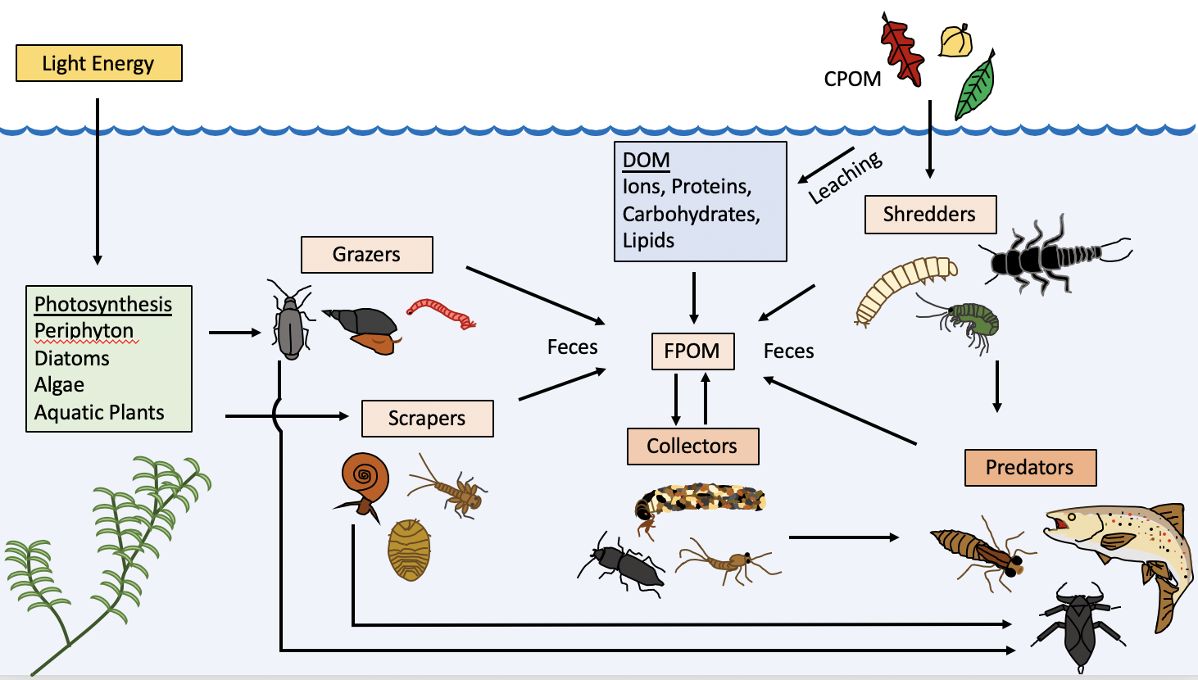

Figure 2. Students sampling aquatic organisms from the catch-and-release section of the Taylor River, CO. Top left: Students receiving instruction (from DDH) on how to deploy drift nets. Top right and bottom left: Groups of students picking through kick net samples and sorting organisms by taxonomic group and/or presumed trophic level. Bottom right: Students pulling drift nets to conclude the sampling exercise.

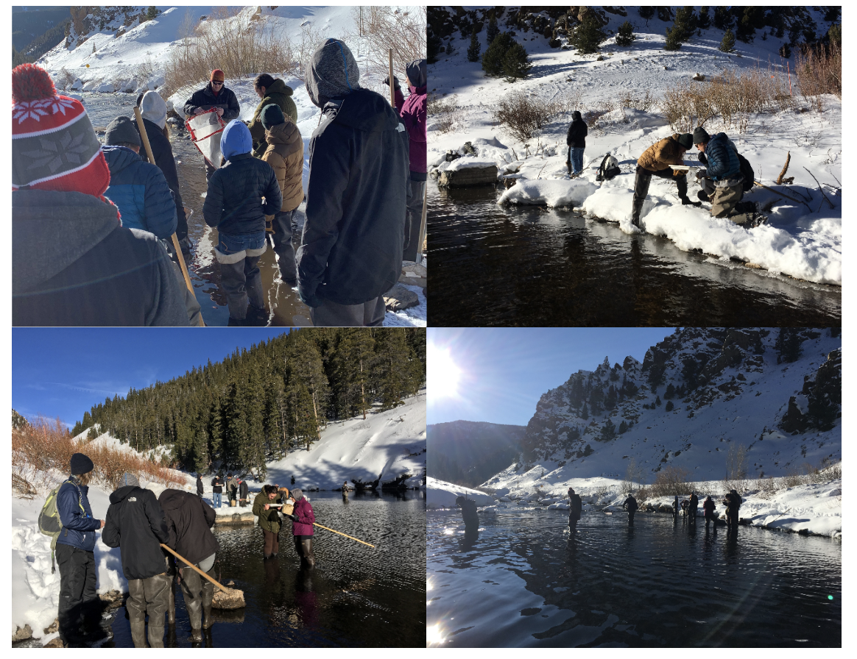

Figure 3. Student example of dual isotopes plots. Left panel: Prior to removal of outliers. Right panel: Outliers removed.

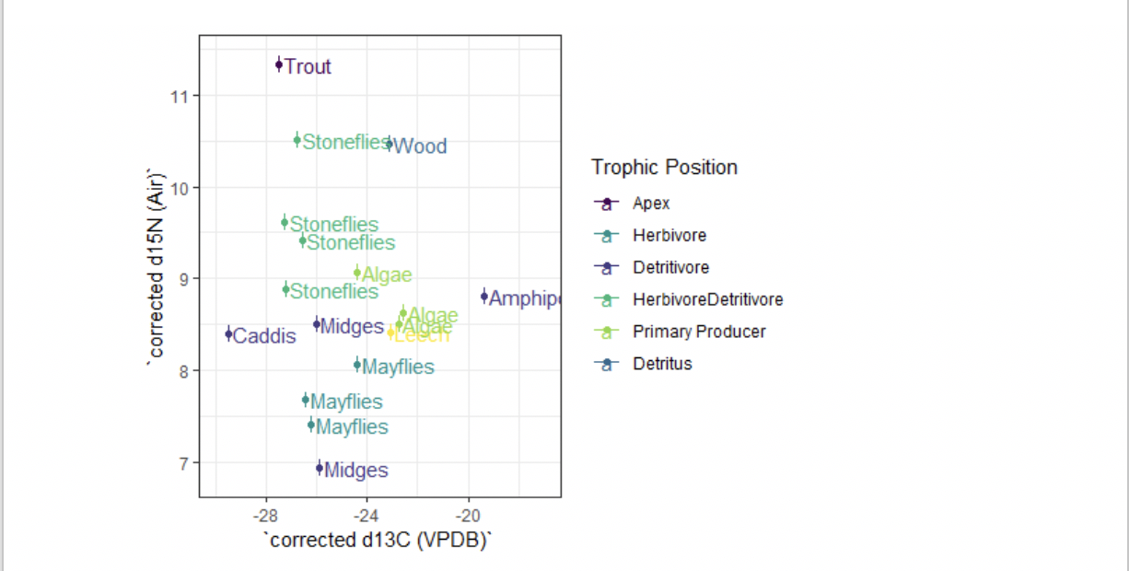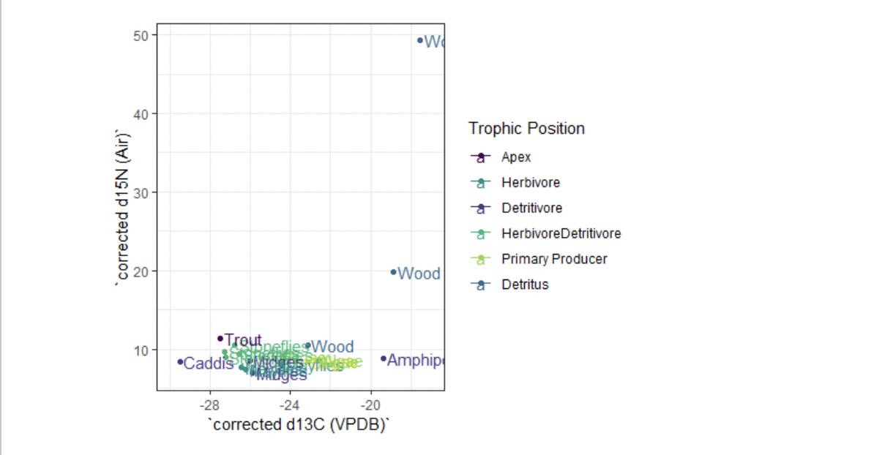

Figure 4. Student example of histograms using isotope data. Top panel: Full data set; Middle panel: One outlier removed; Bottom panel: Second outlier removed. Students were asked to describe the distributions, justify cutoff points for the removal of outliers, and write lines of code to remove outliers in the R tutorial. Removal of outliers was justified by the abnormal isotopic signal of two wood (detritus) samples that may have been caused by samples not being thoroughly cleaned and dried, or were contaminated by microbial activity.

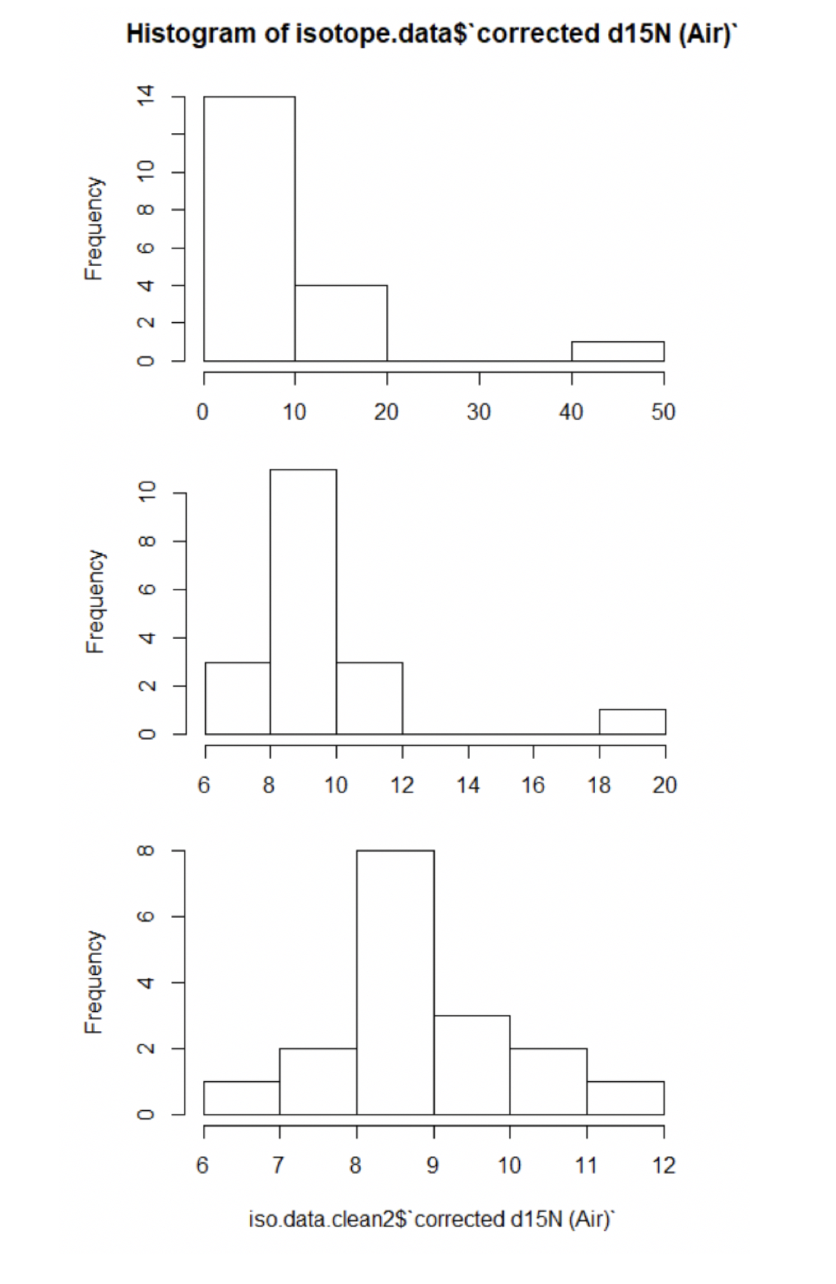

Figure 5. Student example of a pairwise Euclidean distance matrix comparing various trophic categories. Color coding ranges from blue (completely similar) to dark orange (highly dissimilar). Students received instruction on how to interpret these pairwise differences, then were assigned to reassess their preliminary trophic level designations.

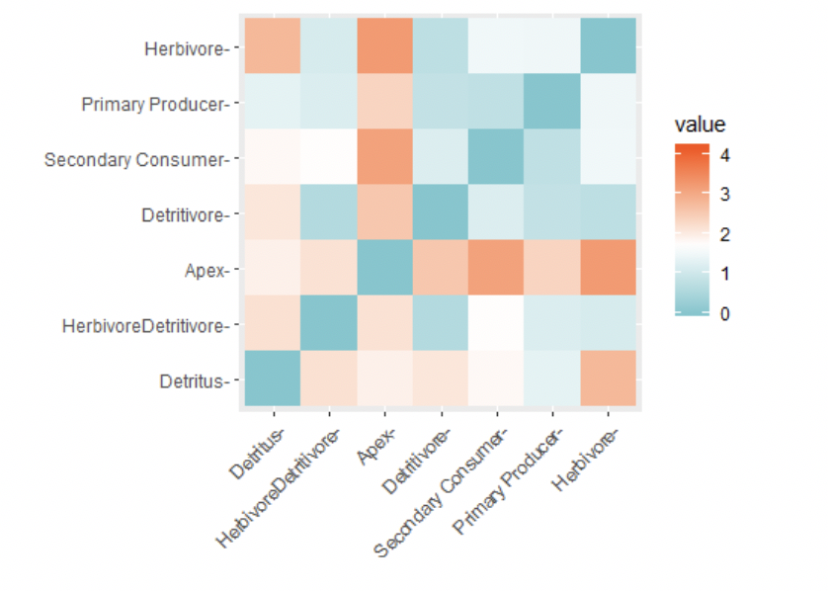

Figure 6. Student example of a cluster plot grouping samples together based on corrected δ13C and δ15N values. Students were instructed to produce numerous plots, using different numbers of clusters, then select the number of clusters they felt best represented the data and explain why in the R notebook tutorial and in their laboratory report.

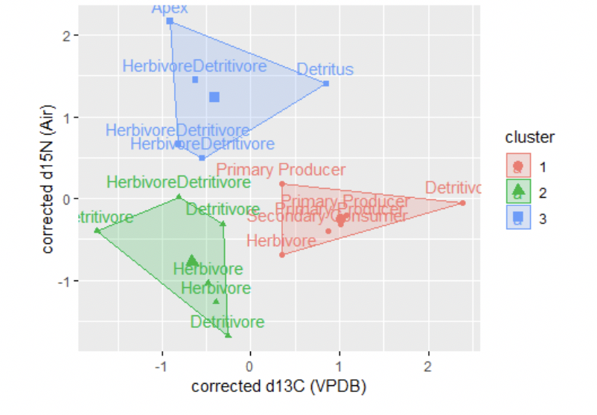

Table 1. Biological samples students acquired from the catch-and-release area of the Taylor River, below Taylor Park Reservoir, CO. Samples were assigned a taxonomic classification, categorized by trophic level, and assigned a unique sample identification number.

|  |  |  |  |  |  |
| --- | --- | --- | --- | --- | --- |
| Sample # | Group # | Presumed Trophic Level (by Students) | Biological Classification | Sample ID | Common Name |
| 1 | 1 | Secondary consumer | Annelida | G1PAANS1 | Leech |
| 2 | 1 | Grazer | Amphipoda | G1GRAMS2 | Scud1 |
| 3 | 1 | Grazer | Plecoptera | G1GRPLS3 | Stonefly |
| 4 | 1 | Grazer | Ephemeroptera | G1GREPS4 | Mayfly |
| 5 | 1 | Collector | Chironomidae | G1COCHS5 | Midge2 |
| 6 | 1 | Detritus | Unidentified Plant | G1DEDES6 | Twig |
| 7 | 2 | Detritus | Unidentified Plant | G2DEDES1 | Twig |
| 8 | 2 | Grazer | Chironomidae | G2GRCHS2 | Midge |
| 9 | 2 | Grazer | Amphipoda | G2GRAMS3 | Scud1 |
| 10 | 2 | Grazer | Ephemeroptera | G2GREPS4 | Mayfly |
| 11 | 2 | Grazer | Plecoptera | G2GRPLS5 | Stonefly |
| 12 | 2 | Producer | Algae | G2PRALS6 | Algae3 |
| 13 | 3 | Shredder | Plecoptera | G3SHPLS1 | Stonefly |
| 14 | 3 | Collector | Chironomidae | G3COCHS2 | Midge4 |
| 15 | 3 | Shredder | Ephemeroptera | G3SHEPS3 | Mayfly |
| 16 | 3 | Producer | Algae | G3PRALS4 | Algae |
| 17 | 3 | Detritivore | Amphipoda | G3DEAMS5 | Scud1 |
| 18 | 3 | Apex Predator | Salmonidae | G3APSAS6 | Brown Trout |
| 19 | 4 | Producer | Algae | G4PRALS1 | Algae3 |
| 20 | 4 | Grazer | Ephemeroptera | G4GREPS2 | Mayfly5 |
| 21 | 4 | Detritus | Unidentified Plant | G4DEDES3 | Twig6 |
| 22 | 4 | Grazer | Chironomidae | G4GRCHS4 | Midge4 |
| 23 | 5 | Detritus | Unidentified Plant | G5DEDES1 | Twig6 |
| 24 | 5 | Producer | Algae | G5PRALS2 | Algae |
| 25 | 5 | Shredder | Trichoptera | G5SHTRS3 | Caddisfly |
| 26 | 5 | Grazer | Chironomidae | G5GRCHS4 | Midge5 |

1 Amphipod samples that were pooled by the instructor after drying to ensure that the minimum quantity requirement was met

2 Sample included a single midge that did not meet the minimum size requirements, but also appeared to be a different species from other samples, so this sample was omitted from further analysis

3 Algal samples that were pooled by the instructor after drying to ensure that the minimum quantity requirement was met

4 Midge samples that were pooled by the instructor after drying to ensure that the minimum quantity requirement was met

5 Misidentified samples – these samples were the same species of stonefly, not midges, and were pooled by the instructor after drying

6 Detritus samples that were pooled by the instructor after drying to ensure that the minimum quantity requirement was met

Table 2. Corrected δ13C (VPDB) and δ15N (air) values for 19 biological samples collected by students for this laboratory exercise. δ13C values are negative as a result of fractionation. Percent concentrations of C and N, taxonomic identifiers, and presumed trophic levels are also provided.

|  |  |  |  |  |  |  |
| --- | --- | --- | --- | --- | --- | --- |
| Sample ID | Identifier | Trophic Level | δ13C | δ15N | %C | %N |
| G1PAANS1 | Leech | Secondary Consumer | -23.0996 | 8.4066 | 40.30 | 9.19 |
| G1GRAMS2, G2GRAMS3,  G3DEAMS5 pooled | Amphipods | Detritivore | -19.3656 | 8.8039 | 40.25 | 8.10 |
| G1GRPLS3 | Stoneflies | Herbivore/Detritivore | -26.5808 | 9.4175 | 50.19 | 10.32 |
| G1GREPS4 | Mayflies | Herbivore | -24.3762 | 8.0686 | 48.65 | 10.43 |
| G1DEDES6 | Wood | Detritus | -18.8707 | 19.8014 | 49.35 | 0.92 |
| G4DEDES3, G5DEDES1 pooled | Wood | Detritus | -23.1492 | 10.4616 | 44.40 | 1.83 |
| G5PRALS2 | Algae | Primary Producer | -24.3774 | 9.0614 | 22.42 | 3.05 |
| G5SHTRS3 | Caddis | Detritivore | -29.5126 | 8.3965 | 47.34 | 9.08 |
| G4GREPS2, G5GRCHS4 pooled | Stoneflies | Herbivore/Detritivore | -27.2451 | 8.8833 | 48.78 | 10.10 |
| G2DEDES1 | Wood | Detritus | -17.5385 | 49.2551 | 50.21 | 0.18 |
| G2GRCHS2 | Midges | Detritivore | -26.0133 | 8.5001 | 49.56 | 9.67 |
| G2GREPS4 | Mayflies | Herbivore | -26.2009 | 7.4077 | 45.50 | 9.20 |
| G2GRPLS5 | Stoneflies | Herbivore/Detritivore | -26.7829 | 10.5149 | 47.04 | 10.78 |
| G2PRALS6, G4PRALS1 pooled | Algae | Primary Producer | -22.5818 | 8.6208 | 21.69 | 2.75 |
| G3COCHS2, G4GRCHS4 pooled | Midge | Detritivore | -25.8693 | 6.9379 | 37.59 | 7.83 |
| G3SHPLS1 | Stoneflies | Herbivore/Detritivore | -27.2536 | 9.6177 | 49.34 | 10.35 |
| G3SHEPS3 | Mayflies | Herbivore | -26.4283 | 7.6753 | 49.37 | 9.75 |
| G3PRALS4 | Algae | Primary Producer | -22.7512 | 8.5011 | 16.44 | 2.22 |
| G3APSAS6 | Trout | Apex Predator | -27.4798 | 11.3337 | 29.98 | 8.89 |

Table 3. Results of student learning outcomes.

|  |  |  |
| --- | --- | --- |
| SLO # | Assessment Method | Success Rate |
| SLO1 | Successful capture of a variety of aquatic organisms by students | 100% |
| SLO2 | Determination of broad taxonomic categories by students, corrected when necessary by the instructor (see Table 1) | 92.3% |
| SLO3 | Tentative assignment of samples to a trophic level by students, with justification to the instructor for why (these were reassessed later in the R tutorial) | 100% |
| SLO4 | Laboratory activities supervised by the instructor and/or teaching assistant | 100% |
| SLO5 | Graded R tutorial with numerous questions answered (including a bonus question; Supplemental File 1) | 104% |
| SLO6 | Graded laboratory report modeled after a peer-reviewed scientific article | 82.2% |
| SLO7 | Graded pre-laboratory worksheets covering stream ecology terminology | Not assessed |
| SLO8 | Graded pre-laboratory worksheets covering stable isotopes terminology | Not assessed |

**Acknowledgements**

We thank Kevin Alexander for sharing knowledge of aquatic invertebrates in the Taylor river, Jacqueline Galang for testing the introductory and advanced R exercises and providing feedback, Justin Conover for reviewing earlier versions of R code, Miles Perry for information technology support, Kayla Wernsing for assisting with isotope sample processing in the SIPERG lab, Nocona Swindell for assisting with student instruction in the field and laboratory, and Lynn Clark for comments which improved the quality of the manuscript. This work was funded entirely by student course fees; no outside funding was obtained.

**References**

Baker, J. L., M. S. Lachniet, O. Chervyatsova, Y. Asmerom, and V. J. Polyak. 2017. Holocene warming in western continental Eurasia driven by glacial retreat and greenhouse forcing. Nature Geoscience 10:430.

Bearhop, S., R. W. Furness, G. M. Hilton, and S. C. Votier. 2003. A forensic approach to understanding diet and habitat use from stable isotope analysis of (avian) claw material. Functional Ecology 17:270–275.

Bearhop, S., G. M. Hilton, S. C. Votier, and S. Waldron. 2004. Stable isotope ratios indicate that body condition in migrating passerines is influenced by winter habitat. Proceedings of the Royal Society of London. Series B: Biological Sciences 271:215–218.

Boschker, H., and J. Middelburg. 2002. Stable isotopes and biomarkers in microbial ecology. FEMS Microbiology Ecology 40:85–95.

Bridgham, S. D., J. P. Megonigal, J. K. Keller, N. B. Bliss, and C. Trettin. 2006. The carbon balance of North American wetlands. Wetlands 26:889–916.

Busst, G. M. A., and J. R. Britton. 2018. Tissue-specific turnover rates of the nitrogen stable isotope as functions of time and growth in a cyprinid fish. Hydrobiologia 805:49–60.

Cerling, T. E. 1984. The stable isotopic composition of modern soil carbonate and its relationship to climate. Earth and Planetary Science Letters 71:229–240.

Chappuis, E., V. Seriñá, E. Martí, E. Ballesteros, and E. Gacia. 2017. Decrypting stable-isotope (δ13C and δ15N) variability in aquatic plants. Freshwater Biology 62:1807–1818.

Cummins, K. W., and M. J. Klug. 1979. Feeding Ecology of Stream Invertebrates. Annual Review of Ecology and Systematics 10:147–172.

Cummins, K. W., M. A. Wilzbach, D. M. Gates, J. B. Perry, and W. Bruce. 1989. Shredders and Riparian Vegetation stream invertebrates. BioScience 39:24–30.

DeNiro, M. J., and S. Epstein. 1976. You are what you eat (plus a few ‰): The carbon isotope cycle in food chains. Geological Society of America Abstracts with Programs 8:834–835.

Divine, L. M., B. A. Bluhm, F. J. Mueter, and K. Iken. 2017. Diet analysis of Alaska Arctic snow crabs (Chionoecetes opilio) using stomach contents and δ13C and δ15N stable isotopes. Deep-Sea Research Part II: Topical Studies in Oceanography 135:124–136.

Epstein, S., R. Buchsbaum, H. A. Lowenstam, and H. C. Urey. 1953. Revised carbonate-water isotopic temperature scale. Bulletin of the Geological Society of America 64:1315–1326.

France, R. L., and R. H. Peters. 1997. Ecosystem differences in the trophic enrichment of13C in aquatic food webs. Canadian Journal of Fisheries and Aquatic Sciences 54:1255–1258.

Fry, B. 2006. Stable Isotope Ecology. Springer New York, New York.

Hershey, A. E., R. M. Northington, J. C. Finlay, and B. J. Peterson. 2017. Stable Isotopes in Stream Food Webs. Page Methods in Stream Ecology: Third Edition. Elsevier Inc.

Hilderbrand, G. V., S. D. Farley, C. T. Robbins, T. A. Hanley, K. Titus, and C. Servheen. 1996. Use of stable isotopes to determine diets of living and extinct bears. Canadian Journal of Zoology 74:2080–2088.

Hill, S. B., S. Wilson, and K. Watson. 2004. Learning Ecology. A New Approach to Learning and Transforming Ecological Consciousness. Pages 47–64 *in* E. V. O’Sullivan and M. M. Taylor, editors. Learning Toward an Ecological Consciousness: Selected Transformative Practices. Palgrave Macmillan US.

Hobson, K. A. 2016. Tracing Origins and Migration of Wildlife Using Stable Isotopes : A Review. Oecologia 120:314–326.

Hobson, K. A., J. F. Piattt, and J. Pitocchelli. 1994. Using Stable Isotopes to Determine Seabird Trophic Relationships. Journal of Animal Ecology 63:786–798.

Hogan, J. D., M. J. Blum, J. F. Gilliam, N. Bickford, and P. B. McIntyre. 2014. Consequences of alternative dispersal strategies in a putatively amphidromous fish. Ecology 95:2397–2408.

Hsieh, J. C. C., and C. J. Yapp. 1999. Stable carbon isotope budget of CO2 in a wet, modern soil as inferred from Fe(CO3)OH in pedogenic goethite: Possible role of calcite dissolution. Geochimica et Cosmochimica Acta 63:767–783.

Jardine, T. D., M. A. Gray, S. M. McWilliam, and R. A. Cunjak. 2005. Stable Isotope Variability in Tissues of Temperate Stream Fishes. Transactions of the American Fisheries Society 134:1103–1110.

Körner, C., G. D. Farquhar, and Z. Roksandic. 1988. A global survey of carbon isotope discrimination in plants from high altitude. Oecologica 74:623–632.

Lipp, J., P. Trimborn, P. Fritz, H. Moser, B. Becker, and B. Frenzel. 1991. Stable isotopes in tree ring cellulose and climatic change. Tellus 43B:322–330.

McDermott, F. 2004. Palaeo-climate reconstruction from stable isotope variations in speleothems: A review. Quaternary Science Reviews 23:901–918.

Merritt, R., and K. Cummins. 1996. An introduction to the aquatic insects of North America. 3rd edition. Kendall/Hunt Publishing Company, Dubuque, IA.

Molles, M., and A. Sher. 2019. Ecology: Concepts & Applications 8th edition. McGraw Hill Education.

O’Leary, M. H. 1988. Carbon Isotopes in Photosynthesis. BioScience 38:328–336.

O’Reilly, C. M., S. R. Alin, P.-D. Plisnier, A. S. Cohen, and B. A. McKee. 2003. Climate change decreases aquatic ecosystem productivity of Lake Tanganyika, Africa. Nature 424:766–768.

O’Reilly, C. M., R. E. Hecky, A. S. Cohen, and P. D. Plisnier. 2002. Interpreting stable isotopes in food webs: Recognizing the role of time averaging at different trophic levels. Limnology and Oceanography 47:306–309.

Parnell, A. 2019. simmr: A stable isotope mixing model.

Patterson, D. B., D. R. Braun, K. Allen, W. A. Barr, A. K. Behrensmeyer, M. Biernat, S. B. Lehmann, T. Maddox, F. K. Manthi, S. R. Merritt, S. E. Morris, K. O. Brien, J. S. Reeves, B. A. Wood, and R. Bobe. 2019. Comparative isotopic evidence from East Turkana supports a dietary shift within the genus Homo. Nature Ecology & Evolution 3:1048–1056.

Peterson, B. J., and B. Fry. 1987. Stable Isotopes in Ecosystem Studies. Annual Review of Ecology and Systematics 18:293–320.

Reynolds, D. J., I. R. Hall, J. D. Scourse, C. A. Richardson, A. D. Wanamaker, and P. G. Butler. 2017. Biological and Climate Controls on North Atlantic Marine Carbon Dynamics Over the Last Millennium: Insights From an Absolutely Dated Shell-Based Record From the North Icelandic Shelf. Global Biogeochemical Cycles 31:1718–1735.

Reynolds, D. J., J. D. Scourse, P. R. Halloran, A. J. Nederbragt, A. D. Wanamaker, P. G. Butler, C. A. Richardson, J. Heinemeier, J. Eiríksson, K. L. Knudsen, and I. R. Hall. 2016. Annually resolved North Atlantic marine climate over the last millennium. Nature Communications 7:13502.

Richards, M. P., P. B. Pettitt, E. Trinkaus, F. H. Smith, M. Paunovic, and I. Karavanic. 2000. Neanderthal diet at Vindija and Neanderthal predation: The evidence from stable isotopes. Proceedings of the National Academy of Sciences 97:7663–7666.

Rubenstein, D. R., C. P. Chamberlain, R. T. Holmes, M. P. Ayres, J. R. Waldbauer, G. R. Graves, and N. C. Tuross. 2002. Linking breeding and wintering ranges of a migratory songbird using stable isotopes. Science 295:1062–1065.

Rubenstein, D. R., and K. a. Hobson. 2004. From birds to butterflies: Animal movement patterns and stable isotopes. Trends in Ecology and Evolution 19:256–263.

Sharp, Z. 2007. Principles of Stable Isotope Geochemistry. 1st edition. Pearson/Prentice Hall, Saddle River, NJ.

Steinbeiss, S., G. Gleixner, and M. Antonietti. 2009. Effect of biochar amendment on soil carbon balance and soil microbial activity. Soil Biology and Biochemistry 41:1301–1310.

Team, R. D. C. 2015. R: A Language and Environment for Statistical Computing. R Foundation for Statistical Computing, Vienna, Austria.

Thomas, S. M., and T. W. Crowther. 2015. Predicting rates of isotopic turnover across the animal kingdom: A synthesis of existing data. Journal of Animal Ecology 84:861–870.

Wanamaker, A. D., K. J. Kreutz, H. W. Borns, D. S. Introne, S. Feindel, S. Funder, P. D. Rawson, and B. J. Barber. 2007. Experimental determination of salinity, temperature. growth, and metabolic effects on shell isotope chemistry of Mytilus edulis collected from Maine and Greenland. Paleoceanography 22:1–12.

Wassenaar, L., and K. Hobson. 1998. Natal origins of migratory monarch butterflies at wintering colonies in Mexico: New isotopic evidence. Proceedings of the National Academy of Science 95:4.

West, J. B., G. J. Bowen, T. E. Cerling, and J. R. Ehleringer. 2006. Stable isotopes as one of nature’s ecological recorders. Trends in Ecology and Evolution 21:408–414.

Whitney, N. M., B. J. Johnson, P. T. Dostie, K. Luzier, and A. D. Wanamaker. 2019. Paired bulk organic and individual amino acid δ15N analyses of bivalve shell periostracum: A paleoceanographic proxy for water source variability and nitrogen cycling processes. Geochimica et Cosmochimica Acta 254:67–85.

Wickham, H., R. Francois, L. Henry, and K. Muller. 2009. ggplot2: elegant graphics for data analysis. Springer-Verlag, New York, NY.

Wood, S. 2006. Generalized additive models: an introduction with R. C and Hall.

Vander Zanden M. J., Casselman J. M., and Rasmussen J. B. 1999. Stable isotope evidence for the food web consequences of species invasions in lakes. Nature 401:464–467.